Welcome! This is a guide designed to encourage you to enjoy Gathering Place activities at home. Each Month has a new theme. You can print the document as a whole or only in part. Here you will find everything you need to have a fun, joyful, and active day with your loved one filled with games, crafts, a simple exercise routine, and even a recipe. We hope you enjoy!

Board Games

Word Games and Art Pages
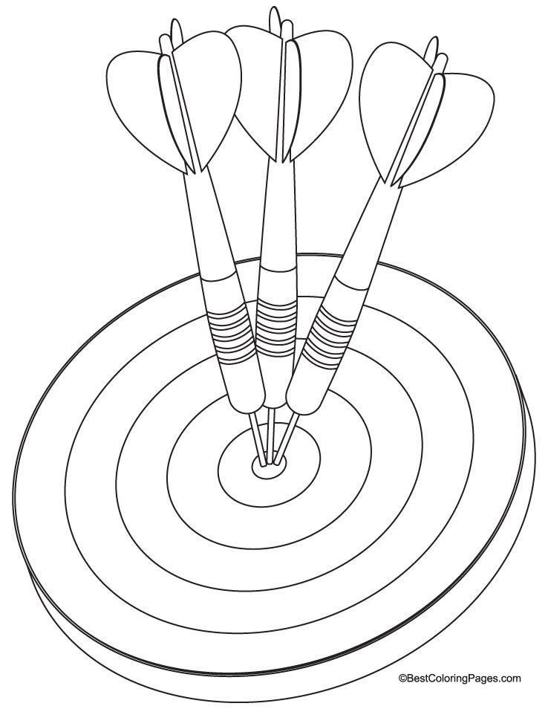
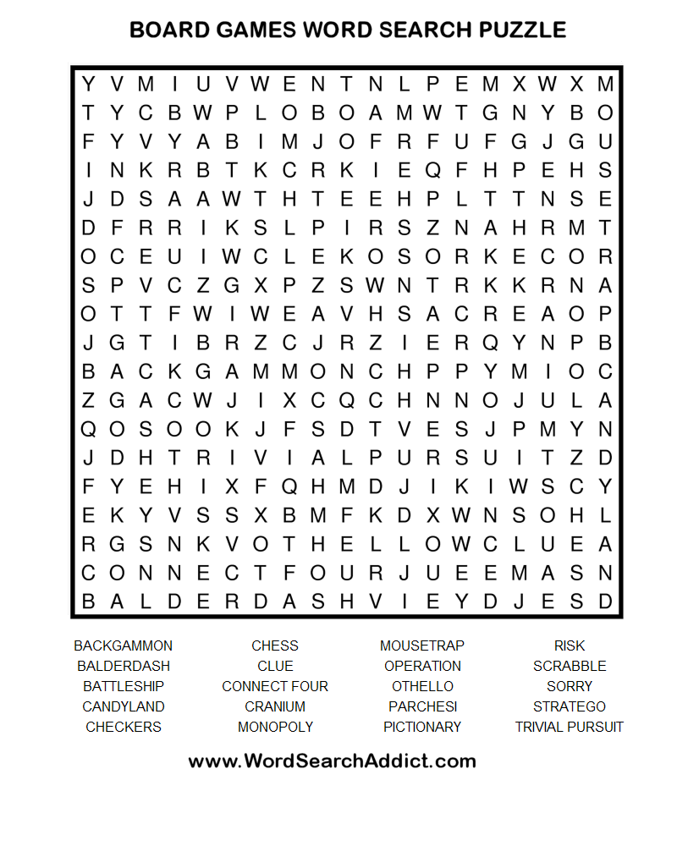
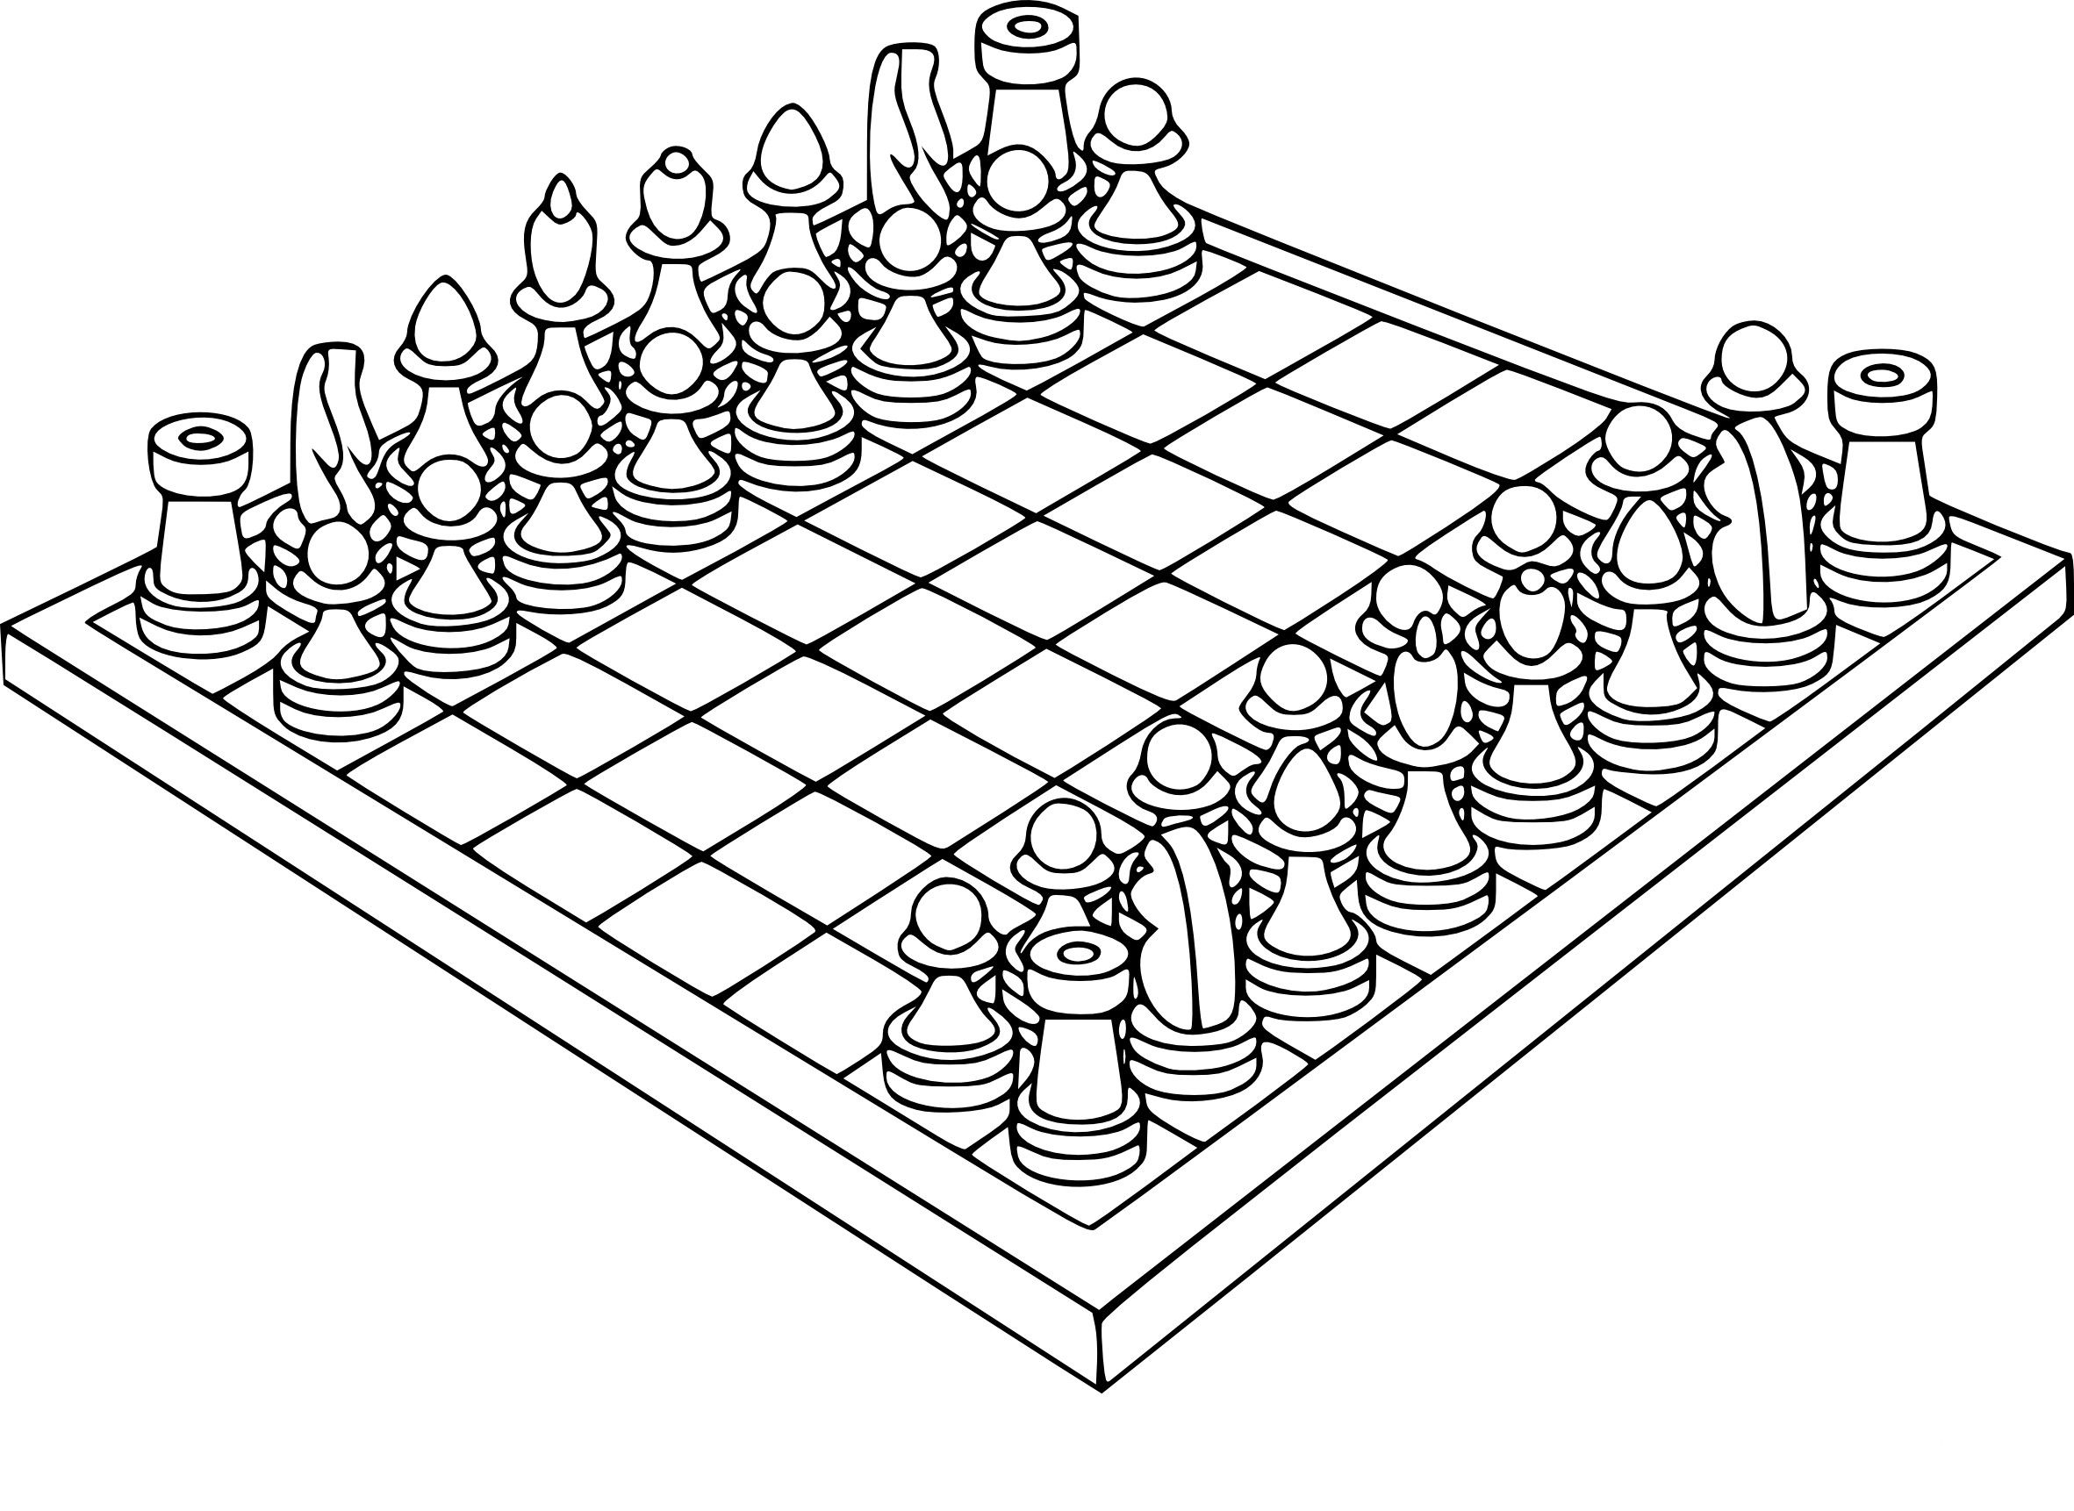
Games and Crafts
We are going to combine Games and Crafts this week and create our own game board. At the end of this document is a sample game board, a dice cutout in case you don’t have any at home, and DIY cards. Use the dice to roll for the spaces you move and create your own directions for each of the cards. Make them silly and fun to keep the game moving. Then have your loved one decorate the board. Print it on thick cardstock or glue to a piece of cardboard to keep the board from moving around too much. The back of a cereal box would work as well. Have your loved one chose an object from around the house as their marker.

The goal of the game is simple, move your marker from start to finish.

Some Examples for the cards (you can make as many as you would like):
Move forward one space
Move backward one space
Move forward two spaces
Sing a song and move forward one space
Dance a jig and trade places with another player.

Another option for a game is attached as well. Roll the dice to decide the number of spaces to move. If your loved one can identify the image they get to stay on the spot. First person to the end

Exercise

At Home Mini-Workout Part Four
Can be done in a chair or standing
Needed:
- Optional: 2 water bottles to use as weights

Warm-Up Routine
- Raise your right arm above your head and lean to the left side, stretching your arm out. Repeat the same with the left arm reaching to the right. Repeat 3 times on each side.
- Lean your head to one side, reaching your ear to your shoulder. Bring it back to center and do the same on the other side. Repeat 3 times.
- Touch your chin to your chest, stretching the back of your neck, and bring back to the center. Point your chin up to the ceiling and bring back to center. Repeat this 3 times.
- Bring your knee up and hold it in place. Slowly bring it down. Lift the other knee, pause, and bring it back down. Repeat 3 times on each side.
- Take a deep breath and march in place at your own pace for 1 minute

Workout Routine
- Sit up with your back straight and feet flat on the floor. Touch your right toes to the right side, with your knee still bent, and then bring your leg back to center. Do the same with your left leg. Repeat 5 times on each side.
- Keep your back straight and put your hands above your head and reach your right elbow to your left knee. Only go as far as you are comfortable. Repeat the same move with the left elbow to the right knee.
- Rest for 30 seconds.
- Pick up a water bottle in each hand (optional) and rest them on your knees, palms up. Curl your hands up to your shoulders. Rotate between your right arm and left, doing this 5 times with each arm.
- Bring your bottles up to your chest and slowly punch out with each arm, repeating the punch 5 times with each arm.
- Repeat the same moves but raise your bottles above your shoulders. (It’s important not to do this if you feel pain or discomfort)
- Rest for 30 seconds.
- Then, bringing your bottles back to your chest, cross one arm to the opposite side, crossing your body. Repeat 5 times with each arm.
- Still holding your bottles, raise your elbows to shoulder level, with hand pointing up. Touch your elbows to each other in front of your chest and then open them to the sides, stretching your chest muscles. Repeat 5 times.
- Resting your arms, do 5 leg lifts on each side, pointing your toes up into the air as far as you can lift.
Cool-Down Routine
- Take a deep breath in and out. Bring your arms straight up from your knees to your shoulder level and up. Hold. Take a deep breath, in and out. Bend at the elbows and bring your arms to the side, stretching your chest. Breath in and out. Bring your elbows back down to your size. Repeat 2 times.
- While breathing deeply, touch your hands to your shoulders, lean to the left, back to center, and to the right. Do this slowly as your breath returns to normal. Great job!
Finished

A Prayer for The Season
By Dr. Maya Angelou

Father, Mother, God,
thank you for your presence
during the hard times and mean days.
For then we have you to lean upon.

Thank you for your presence
during bright and sunny days,
for then we can share that which we have
with those who have less.

And thank you for your presence
during the Holy Days,
for then we are able
to celebrate you
and our families
and our friends.

For those who have no voice,
we ask you to speak.

For those who feel unworthy,
we ask you to pour your love out
in waterfalls of tenderness.

For those who live in pain,
we ask you to bathe them
in the river of your healing.

For those who are lonely,
we ask you to keep them company.

For those who are depressed,
we ask you to shower them
with the light of hope.

Dear Creator, You, the borderless
sea of substance.
We ask you to give all the world
that which we need most – Peace.

Recipe

B L T Casserole

Serves 6

- 12 oz. crusty Italian or country style bread, cut into 1” cubes (about 8 cups)
- 1 lb. thick-cut bacon, cut crosswise into 1” pieces
- 3 large eggs
- 1 ½ C low-sodium chicken stock or broth
- ½ C mayonnaise
- 1 t kosher salt & ¾ t freshly ground black pepper
- pint cherry or grape tomatoes, halved
- head romaine, washed, dried very well, cut into 1” slices
- 2 T coarsely chopped chives (optional)

Preheat oven to 350 degrees

1. Spread bread in a single layer on a rimmed baking sheet. Bake, tossing once, until dry to the touch and slightly toasted, about 10 minutes. Let cool slightly.

2. Meanwhile, cook bacon in a large skillet over medium-high heat, stirring occasionally, until fat starts to render and bacon browns, about 15 minutes. Using a slotted spoon, transfer bacon to a small bowl, reserving 3 T bacon fat.

3. Whisk eggs, stock, mayo, salt, pepper, and 2 T bacon fat in a large bowl. Add break and toss gently to combine. Add bacon and tomatoes and stir to combine. Let sit until bread has absorbed most of the liquid, about 15 minutes.

4. Reduce oven temperature to 325 degrees. Add lettuce to break mixture and stir to combine. Transfer mixture to a 13x9 baking dish and bake until top is golden brown, about 45 minutes. Brush surface with remaining 1 T bacon fat, turn broiler on, and continue baking until the tops of the bread are glistening and well toasted, 3-5 minutes more. Garnish with chives, if using.
Do ahead: Bread can be dried out 3 days ahead; store in an airtight container at room temperature. Bacon can be cooked 3 days ahead; cover and chill.

Epicurious Magazine

START
FINISH
© Teacher’s Pet 2012 www.tpet.co.uk
Dice © Teacher’s Pet 2013 www.tpet.co.uk
©
Teacher’s Pet 2013 www.tpet.co.uk
Cards
Create your own challenge cards for your board game.

